Headline: Summarizes the Most Important Information in an Attention-Grabbing Way
By Your Name

A Picture Might be Nice Here

Pictures need captions that explain what is happening or its significance

LOCATION OF THE INCIDENT, Date Published--

Lead: The lead tells the who, what, where, and when of a story in just a few sentences. A person should be able to get the “gist” of the article from just this short paragraph.
Body #1: Include more facts and elaborate on the details about the story. You may also start discussing the why and the how. When using quotes from witnesses and experts, be sure to make it clear who said it. Also, try to be balanced and neutral in your writing. Avoid biased language and use a professional tone. For instance: if a man/woman hasn’t been convicted of the crime yet, don’t call him/her a murderer. Instead, try calling him/her by their name or

use a phrase like “the defendant” if they have been arrested.
Body #2: Even more information and details about the story. Notice that this is only 151 words so far and you will need to write at least twice that for this article. Do you have any relevant statistics? Because those would go well in your second and/or third body paragraphs. Another idea is to include a chart or graph to go along with your story. Obviously this wouldn’t be relevant for all kind of news articles (example: “Lost Pet Found!”) but for, say, a local robbery, it might be useful to have the crime statistics in a graph like below. This provides context so that the reader can make sense of the story.

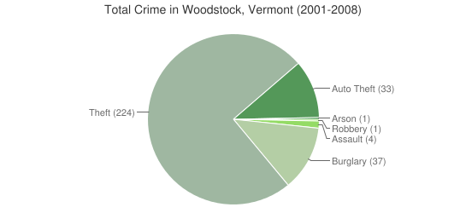
Crime in the Woodstock, Vermont

Analyze your graph. For example, you may notice that, of all of the crime in Woodstock, robbery was the least common.
Hey, look! Now we’ve hit 281 words! That’s pretty good. Now you want to wrap up your article with any final thoughts or maybe a quote from an expert or witness on the subject. Remember: this is still about the story-- not your opinion. Avoid “I” statements. (final word count: 323)

